**AstroSage Project Documentation**

**Vikas Upadhyay**

**Observations and insights for Objective and Subjective questions:**

**Objective Question:**

1. **What is the total no. of tables present in the data?**

**Ans:** The total no. of tables present in the data are 3 i.e. Data, Dashboard and Pivot and charts.

1. **What is the total no. of attributes present in the data?**

**Ans**: There are 45 attributes present in the data sheet.

1. **The data consists of some inconsistent and missing values so ensure that the data used for further analysis is cleaned.**

**Ans:**

**Data Cleaning Approach:**

1. Remove Duplicates: Eliminate redundant records like duplicate calls.
2. Handle Missing Values: Fill or remove records with missing critical data (e.g., call duration, satisfaction scores).
3. Outlier Detection: Identify and handle anomalies in call duration or satisfaction scores.

**Metrics and Calculations:**

We have identified missing or inconsistent values and clean them to ensure the data is ready for analysis like removing duplicates, filling missing values, fix inconsistencies by using various spreadsheet functions such as if( ), isblank( ), iferror( ), trim( ), proper( ), upper( ), datevalue( ), text( ), hour(), day() etc. and we have used various functions such as sum, average, count, percentage, correlation and absolute etc.

1. **What is the average daily call volume over the day by day and what’s the change on it**

**Ans:**

Guidelines: It refers to analysing the pattern of incoming calls in a call centre on a daily basis. Make use of conditional aggregators and operators to calculating the average number of calls received per day and to looking at the specific number of calls received each day. It helps identify if certain days have higher or lower call volumes than others. We can also track how the call volume changes over time from one day to another.

**Visualization:**

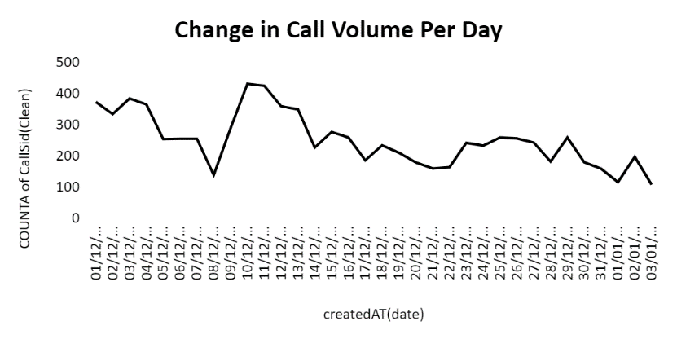

Change in Call Volume = Current Day's Call Volume - Previous Day's Call Volume

Average Daily Call Volume = SUM(Daily Call Volumes) / Number of Days

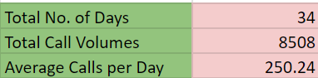

**Observation:**

The purpose is to Understand the daily call volume trends helps in identifying busy periods and can assist in resource planning for the call centre, such as adjusting staffing levels or preparing for high-demand days.

The graph suggests that the call centre experiences busy periods around mid-December. However, there’s also a noticeable drop in call duration near the end of the month.

This data could help the call centre to adjust resources, ensuring more agents are available during peak times while potentially scaling back during slower periods.

1. **Which months experienced the highest and lowest call volumes?**

**Ans:**

Guidelines: It refers to identifying which specific months had the most andfewest calls in a given dataset. It helps in understanding when the call centre was busiest and when it was less active. The month with the highest numberof calls indicates a peak period where the call centre had more customer interactions than usual. The month with the lowest number of calls represents a slow period, where fewer customers contacted the call centre.

December -> Highest Call Volume

January -> Lowest Call Volume

**Visualization:**

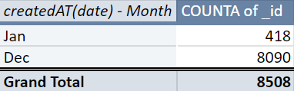

**Observation:**

This chart shows highest and lowest call volume by month in which December has highest call volume as compared to January. Knowing the busiest and slowest months allows management to adjust staffing levels, ensuring that there are enough agents during busy periods and reducing costs during quieter months. It helps the business understand customer behaviour and identify external factors that might be driving call volume trends. December had the highest call volume, with a sum of time duration significantly greater than any other month, especially compared to January. This suggests that December was a very busymonth for the call centre. January experienced the lowest call volume, as shown by the extremely small bar on the chart. December is clearly the busiest month in terms of calls, while January is the quietest month.

1. **What is the total operational cost for that month?**

**Ans:**

* Guidelines: The phrase "for that month" refers to calculating the operational costs for a specific month. Make use of conditional aggregators and operators to approach the problem.

**Visualization:**

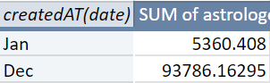

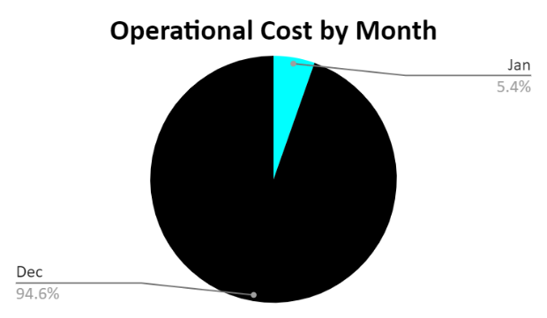

**Observation:**

December had a significantly higher operational cost, exceeding 90,000 units. This suggests that the call centre incurred major expenses during this month. The high operational cost likely correlates with the high call volume seen in December. More agents might have been required, additional resources deployed, and potentially higher infrastructure usage to meet demand.

January shows a much smaller operational cost compared to December, indicating that expenses were minimal during this period. This could be due to the reduced call volume in January, meaning fewer agents and resources were needed to handle the call traffic, leading to lower operational expenses.

There is a clear relationship between call volume and operational cost. As call volume increases (as seen in December), operational costs rise accordingly due to increased resource allocation, agent overtime, or other factors.

Conversely, during months with lower call volume (such as January), the call centre's operational costs are significantly reduced.

1. **What is the average number of calls handled per agent per day?**

**Ans:**

Guidelines: It refers to determining the workload distribution for each agent on a daily basis. It provides insight into how many calls, on average, each agent is managing each day.

**Observation:**

To calculate the average number of calls per agent per day by summing the number of calls per day for all agents and dividing it by the number of agents and the number of days in the dataset.

**Average Calls per Agent per Day =** Calls Handled by All Agents​/ Number of Agents * Number of Days

**Average Calls per Agent per Day = 8508/(148*34) = 1.69**

|  |  |
| --- | --- |
| Total number of Calls | 8508 |
| Total number of Days | 34 |
| Number of Agents | 148 |
| Average No. of Calls | 1.69 |

* If agents are handling a very high number of calls per day (indicating a heavy workload), it may signal the need for hiring more agents, providing additional support, or improving processes.
* Conversely, if agents are handling a very low number of calls per day, it could indicate inefficiency or overstaffing, which could be costing the business in unnecessary expenses.
* It helps to measure the productivity of agents. If an agent can efficiently handle many calls with high customer satisfaction, it shows a productive workforce. However, if the number is too high, the quality of service may decrease, leading to burnout or lower customer satisfaction.
* Based on this metric, the call centre management can determine if they need to hire more agents or if existing agents can handle the current volume effectively.
* It also helps in scheduling — if some days see spikes in call volumes, more agents may need to be scheduled for those days.

1. **How many repeat callers are there, and what percentage of total calls do they represent?**

**Ans:**

Guidelines: It asks for an analysis of the frequency of repeat customers (those who have called more than once) and how much of the total call volume these repeat callers account for. Repeat callers refer to customers who contact the call centre multiple times over a given period.

**Visualization:**

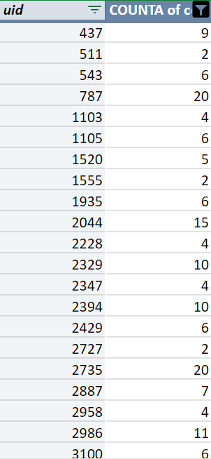 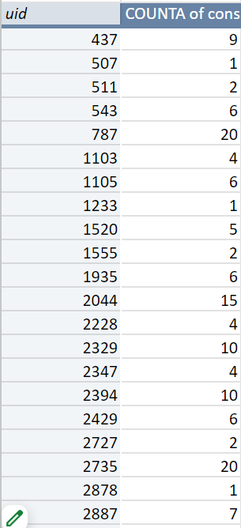

**Observation:**

**Calculate Percentage of Repeated Calls:**

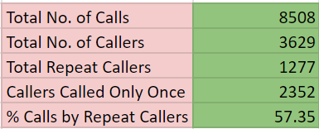

**Repeat callers = Total No. of Callers – Callers Only Called once**

**Percentage of Total Calls that Repeat Callers represent = (Total No. of Calls – Total No. of Callers)/ Total No. of Calls * 100**

**Percentage of Repeated Calls = (8508 - 3629)/ 8508 * 100 = 57.35%**

A high percentage of repeat callers may indicate that customers are not getting their issues resolved in a single interaction, which could be a red flag for poor service or technical issues that require multiple calls to resolve. If the percentage of repeat callers is low, it could indicate that the call centre is successfully addressing customer concerns in the first interaction. High levels of repeat callers can increase the workload for agents and affect efficiency. It suggests that agents might be dealing with the same customer multiple times, which could reduce the number of new customers they can attend to. By identifying the percentage of repeat callers, the centre can evaluate whether they need to improve processes, such as providing better training to agents to resolve issues on the first call or upgrading technology to streamline troubleshooting. Repeat callers may indicate customer loyalty, meaning customers are engaged and willing to call back to resolve issues.

1. **What is the total sales generated by the call centre for each product category?**

**Ans:**

Guidelines: It seeks to determine how much revenue or sales the call centre generated through calls related to different product categories. It involves analysing how much customers spent on various products when engaging with the call centre, providing insights into which product categories are the most profitable for the business.

**Visualization:**

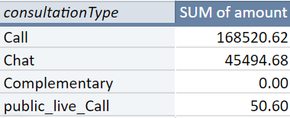

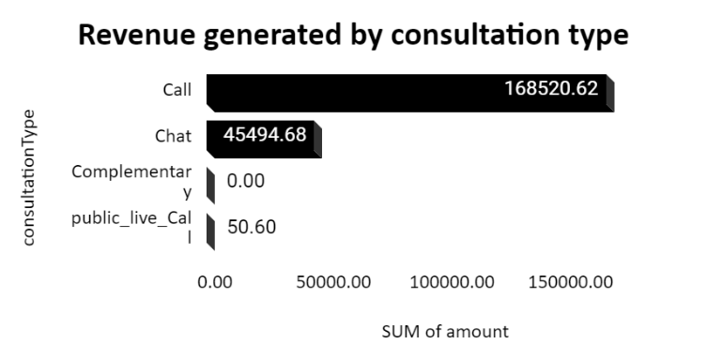

**Observation:**

The Bar chart shows the distribution of the "SUM of amount" among three categories:

Call (168520.62)

Chat (45494.68)

Public live call (50.60) – this portion appears to be too small to register.

A significant majority of the "SUM of amount" is attributed to Calls.

A smaller portion is associated with Chats.

The Public live call category has a negligible or no value at all.

This indicates that Calls are overwhelmingly the most used or significant category compared to the others.

1. **How many calls were made for each user ID and guru ID?**

**Ans:**

* It refers to counting the number of times users and gurus have interacted in some calls. A unique identifier assigned to each user and guru in the dataset. In this case, we want to know how many times a particular user and guru has made or received a call.

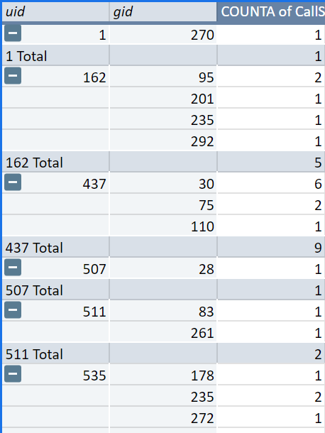 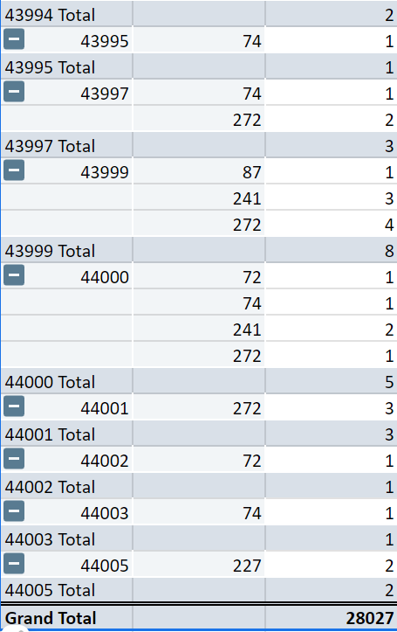

We have Created a pivot table to count calls for each User ID and Guru ID, there are 28027 calls were made for each User ID and Guru ID.

1. **What is the correlation between call duration and customer satisfaction?**

**Ans:**

Guidelines: The question is asking about the relationship between call duration (how long a call lasts) and customer satisfaction (how happy or satisfied the customer is after the call). Specifically, it is trying to find out if there is any correlation between these two factors.

**Visualization:**

**Correlation = CORREL(userOnCallDuration, Rating)**



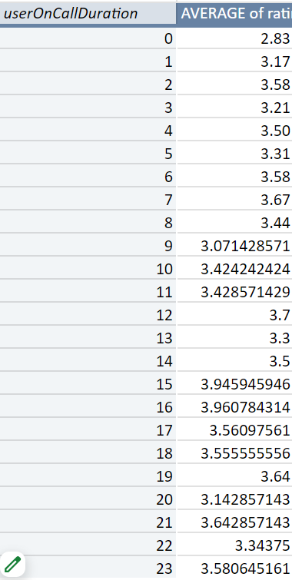

**Observation:**

If there is a positive correlation, it means that as the call duration increases, customer satisfaction also increases. For example, longer calls might give the customer more time to ask questions, leading to higher satisfaction. If there is a negative correlation, it means that as the call duration increases, customer satisfaction decreases. For instance, longer calls might be frustrating for customers, leading to lower satisfaction. If there is no correlation, it means that call duration and customer satisfaction are not related, and one doesn’t impact the other directly. This analysis could help improve service quality by determining whether the length of a call impacts how satisfied customers are and potentially adjusting service delivery accordingly.

1. **Which guru have the highest and lowest customer satisfaction scores?**

**Ans:**

Guidelines: Analyse which guru have the highest and lowest customer satisfaction scores.

Guru with the highest customer satisfaction score: This is the guru who consistently receives the best ratings or feedback from customers.

Guru with the lowest customer satisfaction score: This is the guru who receives the poorest ratings or feedback.

**Visualization:**

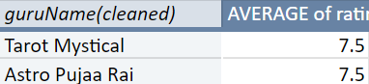

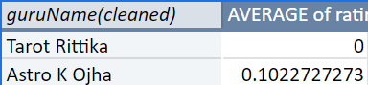

**Guru with the lowest rating – Tarot Rittika**

**Guru with the highest rating – Tarot Mystical & Astro Pujaa Rai**

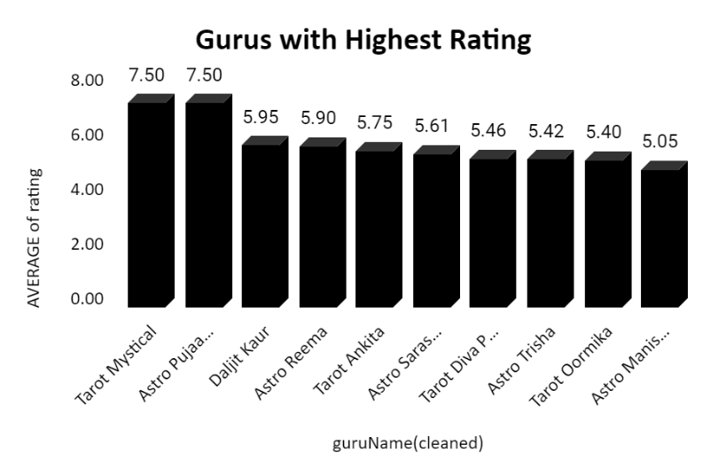

**Observation:**

The chart is showing gurus with highest customer ratings, there can be various reasons for their ratings. Understanding these factors can help in providing training, setting performance benchmarks, and improving overall service quality. High ratings are often driven by strong communication, expertise, empathy, personalized solutions, and professional behaviour and Low ratings typically result from poor communication, lack of knowledge, unprofessional behaviour, slow response times, and failure to address customer problems effectively.

1. **What is the average customer satisfaction score by month?**

**Ans:**

Guidelines: Analysis of customer satisfaction data, broken down by each month. Get the customer satisfaction scores and the dates of the feedback.

Group the data by month.

Calculate the average satisfaction score for each month.

**Visualization:**

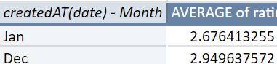

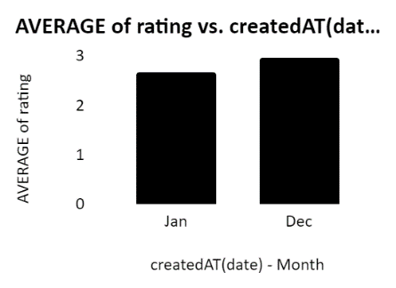

**Observation:**

This chart shows highest and lowest Ratings by month in which December has highest call Ratings as compared to January. It helps to observe how customer satisfaction varies over time (monthly). For example, if satisfaction scores tend to drop in certain months, it might indicate issues with service during those times. This could also help track if any changes in service, staff, or workload affect customer satisfaction. This allows for understanding customer satisfaction patterns over time, helping to identify any seasonal trends or areas of concern during certain months. We can enhance overall performance by identifying patterns.

1. **How many categorical columns are there in the data? [Search about categorical and continuous data, and try to answer this question]**

**Ans:**

**Categorical columns** contain discrete values, such as labels or categories (e.g., names, statuses, types).

**Count of categorical columns**: 34 (These columns contain text, labels, or discrete categories).

Column Names - id, User, Chat Status, guru, guru Name, guru Name(Cleaned), gid, uid, consulation Type, website, refund status, is white list user, queue, free call, free chat, created At, created At (date), day, year, month, hour, updated At, updated At(cleaned), statement Entry Id, chat Start Time, chat Start Time(cleaned), chat End Time, chat End Time(cleaned), correlation, call Channel, caller Type, call Status, Call Sid, Call Sid(Clean), astrologer Call Status, region, user Call Status.

**Continuous columns** contain numerical values that can take any value within a range (e.g., time duration, amounts, ratings).

**Count of continuous columns**: 9 (These columns contain numerical values that are continuous or represent quantities).

Column Names – chat Seconds, time Duration, amount, astrologer On Call Duration, astrologers Earnings, net Amount, operational Cost, user On Call Duration, rating.

**Subjective Question:**

**Investment Overview:**

We have secured an investment of total ₹1 crore, which will be instrumental in driving our strategic initiatives and supporting our growth objectives. This significant funding will be allocated towards specific areas, e.g., expanding our market presence, developing new product lines, enhancing technological infrastructure, etc. This capital injection is a key component of our growth strategy and is expected to drive specific outcomes, e.g., increased operational efficiency, market expansion etc. Ultimately positioning us for sustained success in the competitive landscape.

* 1. **Should the investment be used to hire more agents, improve training programs, or upgrade call centre technology?**

**Ans:**

* **Guidelines:** Deciding whether to allocate the investment towards hiring more agents, improving training programs, or upgrading call centre technology depends on the current state of call centre and the specific challenges we’re facing.

Insights:

To determine whether the investment should be used to hire more agents, improve training programs, or upgrade call centre technology, it's important to consider several factors:

1. Current Call Volume and Agent Workload

2. Quality of Service

3. Efficiency and Scalability

**Hire More Agents**: The data shows long wait times and high call volumes during peak periods.

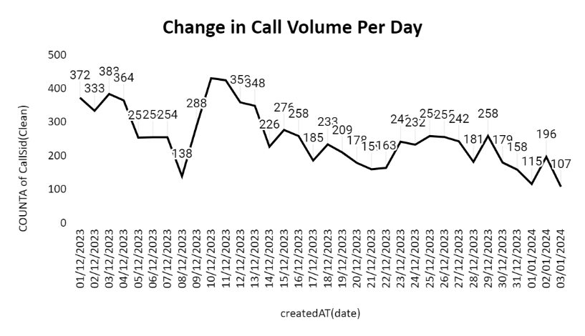

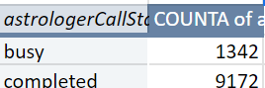 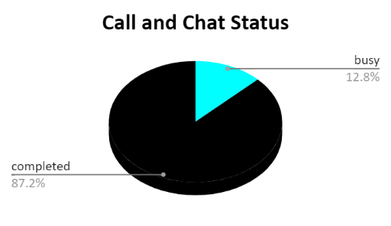

The investment should be used to hire more agents, but simply hiring more agents without improving systems or training could lead to inefficiency and increased operational costs. We should focus on specific things such as improving the training program.

**Improve Training Programs:** The low customer satisfaction scores indicate skill gaps**.** some agents are struggling with performance issues, their average rating is not up to the mark. There can be various factors such as low first-call resolution rates, poor customer satisfaction scores. we you’ve noticed inconsistencies in the quality of customer service.

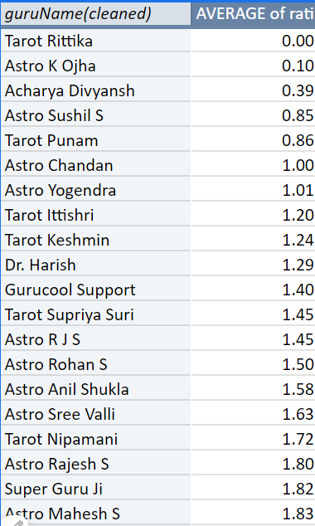

Increases the efficiency and effectiveness of current staff, possibly reducing the need for more agents. Improves customer satisfaction by equipping agents with the skills to resolve issues faster and more effectively.

**Upgrade Technology**: If frequent issues require automation (IVR, chatbots) or outdated systems lead to inefficiencies. Without addressing underlying technology or resource issues, training alone might not solve operational inefficiencies.

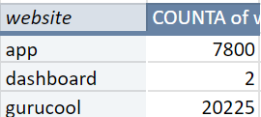 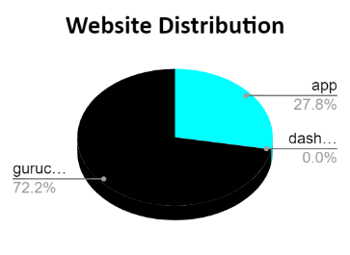

If you’re using outdated systems that cause inefficiencies, such as slow call routing, poor integration with CRM systems, or inadequate automation. Enhances operational efficiency by improving call routing, reducing agent workload, and speeding up response times.

**Recommendations:**

Balanced Approach: If possible, consider a combination of these strategies. Upgrading technology and investing in training to improve agent performance and reduce the need for large-scale hiring.

Assessment: Before making a decision, conduct a thorough assessment of current performance metrics (e.g., call resolution times, customer satisfaction, and agent efficiency) to identify the most pressing need.

1. **What are the potential risks of each investment option (hiring, training, technology upgrades), and how can they be mitigated?**

**Ans:**

**Name the chart/spreadsheet function you will use for solving the problem?**

Guidelines: The potential risks associated with each investment option (hiring, training, and technology upgrades) and strategies to mitigate them and there are various functions and chart to solve this problem.

Insights:

* 1. **Hiring More Agents :** Addresses immediate workload issues and reduces agent burnout during peak times.

Risks:

* Increases operational costs.
* May not improve service quality if existing inefficiencies (technology or processes) remain.

Mitigation: Combine with system upgrades or process improvements to ensure efficient use of new hires.

1. **Improving Training Programs :** Enhances agent performance and Increases efficiency and effectiveness of current staff, reducing the need for more agents.

Risks:

* Training alone may not fix operational inefficiencies caused by outdated technology.
* Inconsistencies in agent performance may persist if not paired with technology improvements.

Mitigation: Tailor training to specific performance gaps and complement it with system enhancements.

1. **Upgrading Call Centre Technology :** Increases operational efficiency, Reduces agent workload through automation, improving response times and productivity, Provides data and analytics for informed decision-making.

Risks:

* Significant upfront investment required.
* Without proper training, agents may struggle to adapt to new systems.

Mitigation : Pair technology upgrades with training and gradual system adoption.

Recommendations:

Combine all three strategies- selective hiring, targeted training, and technology upgrades—to maximize efficiency and performance. This approach addresses both immediate workload concerns and long-term operational improvements.

**Functions** to use:

**SUM()**: To calculate total costs and expected benefits.

**AVERAGE()**: To find average expected benefits across different scenarios.

**IF()**: To evaluate potential outcomes under different conditions.

**Charts for Visualization:**

Bar Chart or Column Chart for Cost Comparison

Pie Chart for Resource Allocation

Line Chart for Expected Impact Over Time

1. **How does Astro Sage call centre performance compare to that of Astro Guru in terms of average call volume, customer satisfaction, and agent performance? Will you use any aggregation function or a visualization here to solve the problem?**

**Ans:**

Guidelines: To compare the call centre performance of Astro Sage and Astro Guru across key metrics like average call volume, customer satisfaction, and agent performance, it would require data from both organizations. However, we have a monthly data of Astro Sage but we do not have data of Astro Guru so we can not compare both of them to each other but we will try to focus on few things related to this scenario.

Insights:

**Average Call Volume**:

**Astro Sage**: If Astro Sage has higher call volumes, it might indicate a broader customer base. However, if customer satisfaction remains high and agents have solid performance (low AHT, high FCR), then this would reflect positively. It could also indicate that Astro Sage has better training programs or superior technology that allows for efficient handling of calls.

**Astro Guru**: Lower call volumes and customer satisfaction at Astro Guru may suggest that customers are dissatisfied, leading to repeat calls or poor service experience. If agent performance (FCR and AHT) is lower, it could be a sign that more investment is needed in training or technology to improve efficiency.

**Comparison Approach**:

**Efficiency per call**: Higher call volumes are only positive if paired with fast and effective resolutions.

**Calls per agent**: You can compare how many calls each agent handles in a day at both companies. Higher calls per agent might indicate better productivity but could lead to burnout if not managed well.

**Customer Satisfaction**:

**Astro Sage**: If customer satisfaction is high, it suggests that agents are resolving customer issues effectively and that customers are satisfied with the service they receive.

**Astro Guru**: A lower customer satisfaction could indicate that customers are unhappy with the response times, the quality of service, or that issues aren't resolved quickly.

**Comparison Approach**:

**CSAT Score**: Compare the average CSAT scores of both call centres. Astro Sage could be outperforming Astro Guru in terms of customer experience if they have higher scores.

**Agent Performance**:

**Astro Sage**: High agent performance can be indicated by metrics like first-call resolution, average handle time, and customer feedback. If agents are well-trained and supported, their performance will reflect positively on the overall efficiency.

**Astro Guru**: If agent performance is lower, it could mean that training or motivation is lacking, or that the call centre technology isn't supporting agents efficiently.

**Comparison Approach**:

**First-Call Resolution** : This metric measures the percentage of issues resolved during the first interaction. A higher FCR in either Astro Sage or Astro Guru would indicate more efficient and skilled agents.

**Average Handle Time** : If Astro Sage has a lower AHT, it means agents are resolving issues more quickly, which can be good if it doesn't compromise service quality. Higher AHT at Astro Guru might suggest agents take longer to handle calls, possibly due to more complex queries or inefficiencies.

Recommendations:

**Gather Metrics**: Collect data on:

* Average daily/monthly call volume.
* Customer Satisfaction (CSAT).
* Agent performance metrics like AHT, FCR, and turnover rate.

**Benchmarking**: Compare these metrics to industry benchmarks to understand if either company is performing above or below average.

To evaluate and compare Astro Sage call centre performance compare to that of Astro Guru in terms of average call volume, customer satisfaction, and agent performance, a combination of charts and spreadsheet functions can be used for a clear, data-driven decision-making process. To comparing Astro Sage and Astro Guru on these parameters using charts e.g. bar charts for volume, line graphs for satisfaction trends to visualize where one outperforms the other.

1. **How can the call centre improve its handling of peak call periods to ensure high customer satisfaction? Mention the functionality which you will use for giving the suggestions, will it be any aggregated function or a visualization?**

**Ans:**

Guidelines: To improve the call centre’s handling of peak call periods while maintaining high customer satisfaction, a combination of data aggregation and visualization would be most effective. Here's how these approaches can help, along with suggestions for improving performance.

Insights:

**Data Collection and Aggregation:**

**Historical Call Data**: Collected data on call volume distribution through out the day and observed that the peak hours in which the higher number of calls were made is between 6 to 11 AM hence we will need more agents to manage the workload better and reduce the man power at the time when the calls are made in less numbers to distribute the work evenly.

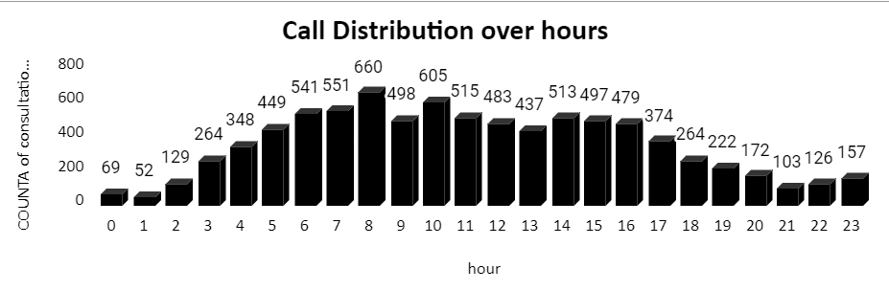

**Agent Performance Metrics**: Gather data on metrics such as average handle time, and agent availability during peak times.

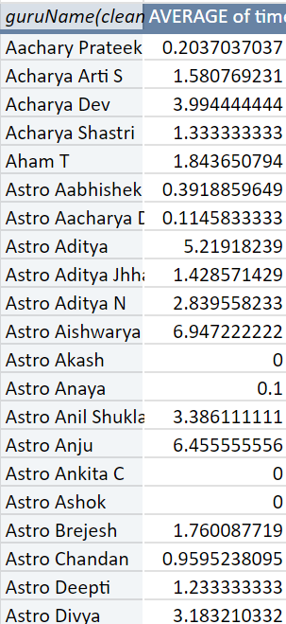

**Customer Satisfaction Scores**: Track rating during different time intervals, particularly during peak periods.

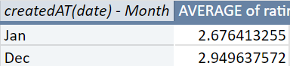 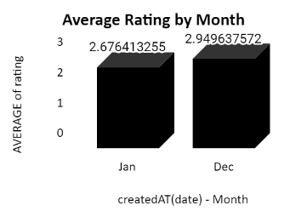

**Offer Callbacks**: Allow customers to request a callback instead of waiting.

 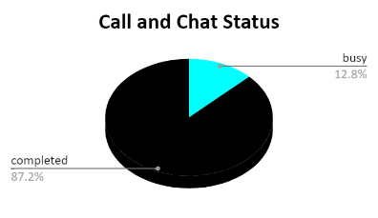

Recommendations:

By leveraging aggregated functions for data analysis and visualization tools for real-time monitoring, the call centre can effectively manage peak call periods. Implementing dynamic scheduling, real-time dashboards, self-service options, and targeted training will enhance operational efficiency and significantly improve customer satisfaction during high-demand times. Regularly analysing performance metrics and customer feedback will ensure continuous improvement and adaptability to changing call volumes.

1. **Based on historical data, what strategic initiatives should be prioritized to improve overall efficiency and customer satisfaction?**

**Ans:**

Guidelines: Based on historical data, prioritizing strategic initiatives to improve overall efficiency and customer satisfaction is crucial for optimizing call centre performance.

Insights:

Based on historical data, the following initiatives should be prioritized:

1. Introduce training programs for agents/astrologers to streamline issue resolution. Enhance agent training to reduce handling time and improve customer interactions. We can reduce waiting period by investing in more agents and their training for better customer satisfaction and resolving their issues. Waiting queue can lead to lower overall customer satisfaction.
2. We can also reward top performers with incentives, promoting their availability during peak times. Upgrade call centre technology to streamline processes and improve agent productivity.
3. By Providing targeted training and coaching to underperforming astrologers. Expand customer communication channels for convenience.
4. Implement a customer relationship management system that tracks user history and preferences. These initiatives will help ensure long-term success in both operational efficiency and customer loyalty.

Recommendations:

To improve overall efficiency and customer satisfaction, there are strategic initiatives.

* 1. **Optimize staffing levels** during peak times using call volume analysis to reduce wait times.
  2. **Enhance training programs** to improve agent performance and first-call resolution rates.
  3. **Invest in technology upgrades**, such as automation for routine queries and real-time call monitoring.
  4. **Monitor key performance indicators** like average handle time, customer satisfaction scores, and service levels to identify areas for improvement.

1. **What can be the key factors contributing to high customer satisfaction scores, and how can these be leveraged to improve overall performance?**

**What is the basis for the suggestions? And mention how did you decide if the satisfaction score affect the ratings?**

**Ans:**

Guidelines: The key factors contributing to high customer satisfaction scores can be derived from the data. By analysing the relationship between certain variables and the customer satisfactionscore (rating), we can identify the most influential factors that improve customer satisfaction.

Insights:

Key Factors Contributing to High Customer Satisfaction:

* **Quick Response Times**: Faster issue resolution boosts satisfaction.
* **First Call Resolution**: Resolving issues in one call minimizes frustration.
* **Friendly and Knowledgeable Agents**: Positive interactions and expertise improve the customer experience.
* **Efficient Problem Handling**: Quick, clear solutions leave customers satisfied.

These can be leveraged to improve overall performance

* **Optimize Staffing** to maintain low wait times.
* **Enhance Agent Training** focusing on knowledge and soft skills.
* **Implement Self-Service Options** to resolve simple queries quickly.
* **Reduce queues** by reallocating resources during peak times.

**Basis for Suggestions:**

**Customer behaviour:** Satisfaction is strongly linked to the quality of service provided.

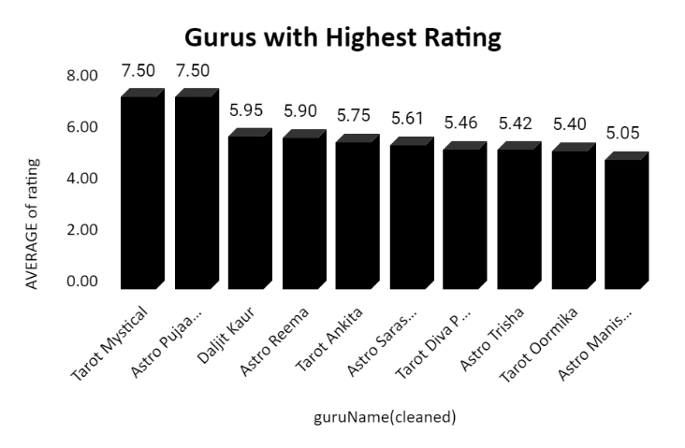

**Data Analysis:** We have used Pivot Tables to identify correlations between variables such as time duration, consultation Type and rating. Higher satisfaction ratings are likely influenced by shorter wait times, better performance by astrologers, and efficient resolution of consultations. As the pivot table below shows the rating by sum of user on call duration, we can anticipate by analysing the rating by call duration.



**How Satisfaction Scores Affect Ratings:**

Use correlation analysis to determine how factors like call duration and astrologer performance impact satisfaction scores.

Employ pivot tables to track performance by astrologer and consultation type.

Recommendations:

The data-driven approach to understanding satisfaction scores allows businesses to identify areas where improvements can have the most significant impact. By aligning resources with the factors that contribute most to customer satisfaction, companies can continuously improve service quality, resulting in a better overall customer experience.

1. **How should the call centre balance the workload among agents to ensure optimal performance and avoid burnout? Mention your approach and spreadsheet function for the answer?**

**Ans:**

Guidelines: Balancing the workload among call centre agents is crucial for maintaining optimal performance and avoiding burnout.

Insights:

**Monitor Call Volume per Agent** – The pivot table shows the number of calls handled by each agent (Guru) over a given period. This will help ensure that calls are distributed evenly among agents to ensure optimal performance and avoid burnout.

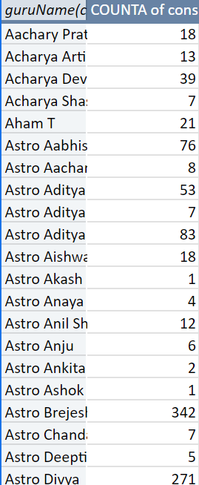

**Evaluate Call Duration and Time on Call** - Agents who handle longer calls may need fewer call assignments, while agents with shorter call durations could handle more calls.

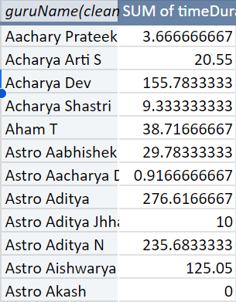

**Assess Agent Performance** - Use metrics like customer satisfaction scores (ratings) to identify top-performing agents. High performers can handle a higher volume, while underperforming agents may need fewer calls and more training.

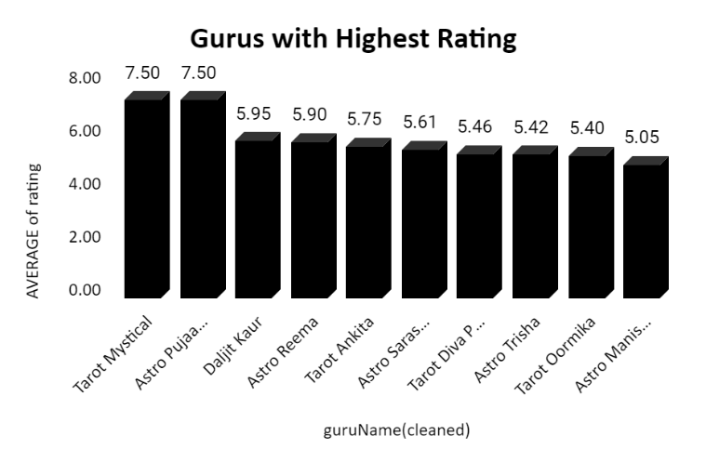

Recommendations:

We can use Pivot Tables to track Calls Handled per Agent, Monitor Average Call Duration per Agent, Evaluate Customer Satisfaction (Rating) and use Excel charts to visualize workload distribution and easily spot imbalances among agents.

1. **What new technologies or tools could be implemented to enhance call center operations and customer service?**

**Ans:**

Guidelines: To enhance call centre operations and customer service, we can consider implementing the following technologies and tools.

Insights:

* **Artificial Intelligence (AI) and Machine Learning (ML)**

**AI Chatbots**: Automate routine inquiries and provide 24/7 support, freeing up agents for more complex issues.

**Predictive Analytics**: Use ML algorithms to predict call volumes, identify trends, and optimize staffing levels.

**Sentiment Analysis**: Analyse customer interactions to gauge sentiment and improve responses.

* **Advanced Customer Relationship Management (CRM) Systems**

**Unified CRM Platforms**: Integrate all customer interactions into a single view for agents to access comprehensive customer histories and provide personalized service.

**Omnichannel Support**: Manage interactions across multiple channels (phone, chat, email, social media) from one platform for seamless customer experiences.

* **Cloud-Based Call Centre Solutions**

**Scalability**: Easily scale operations up or down based on demand without significant infrastructure changes.

**Remote Work Capabilities**: Allow agents to work from anywhere, increasing flexibility and access to a broader talent pool.

* **Interactive Voice Response (IVR) Systems**

**Advanced IVR**: Implement intelligent IVR systems that guide customers to the right department or agent based on their needs, reducing wait times and improving efficiency.

**Speech Recognition**: Use speech recognition to enable natural language processing and better handle customer queries.

* **Workforce Management (WFM) Tools**

**AI-Driven Scheduling**: Automate scheduling and workforce planning using AI to predict demand and optimize shift allocations.

**Real-Time Monitoring**: Use real-time analytics to adjust staffing levels and manage call queues dynamically.

* **Customer Self-Service Portals**

**Self-Service Options**: Provide customers with access to FAQs, knowledge bases, and troubleshooting guides to resolve issues independently.

**Interactive Tutorials**: Offer interactive guides and tutorials to help customers use products or services more effectively.

* **Enhanced Analytics and Reporting**

**Real-Time Dashboards**: Use dashboards for real-time monitoring of key performance indicators (KPIs) and operational metrics.

**Advanced Reporting**: Implement tools that offer detailed insights into call centre performance, customer behaviour, and agent productivity.

Recommendations:

Implementing these technologies can greatly enhance call centre operations by improving efficiency, increasing customer satisfaction, and providing valuable insights into performance. Prioritize solutions that align with your specific needs and goals to achieve the best results.

1. **What metrics should be included in the final dashboard to provide a comprehensive view of call centre performance and guide investment decisions?**

**Ans:**

Guidelines: For a comprehensive call centre dashboard, include the following key metrics to provide a comprehensive view of call centre performance and guide investment decisions.

Insights:

* **Total Revenue** and **Total Net Earnings** over time.

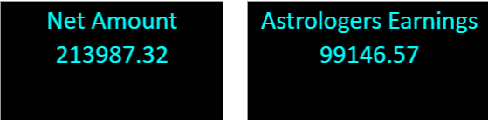

* **User Retention** - Number of repeat users and new users.



* **Consultation Type** - breakdown by revenue and frequency (e.g., calls vs chats).

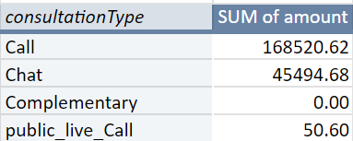

* **Average Satisfaction Score** with trend lines to track improvements or declines.

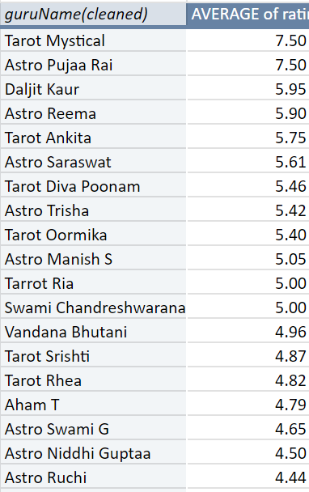

* **Top Performing Gurus** - Breakdown of revenue, rating and user engagement.

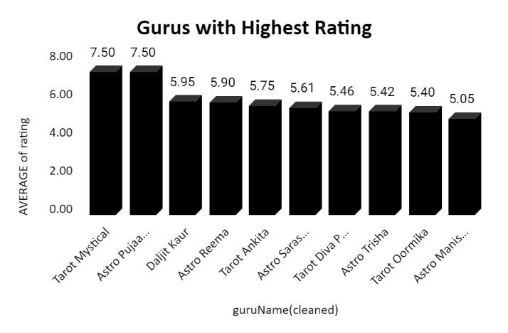

* **Call Volume by Hour/Day**: Helps identify peak times for resource allocation.

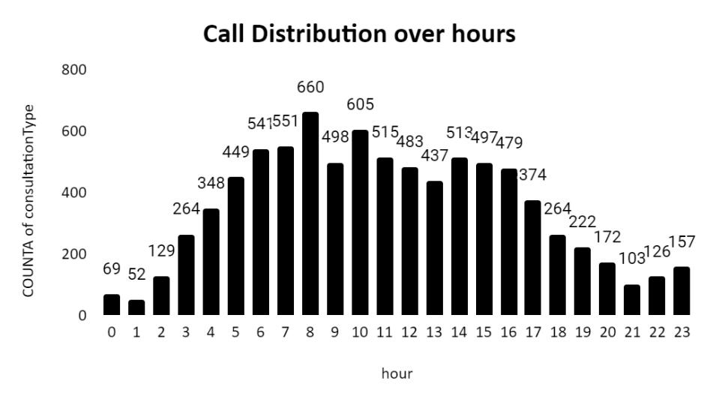

* **Astrologer Performance** - Earnings, call durations, and number of sessions handled by each astrologer.

Recommendations:

Including these metrics in your dashboard will provide a holistic view of call centre performance, helping to identify areas for improvement and guide investment decisions effectively.

1. **How would you allocate a 1 crore rupee investment to optimize operational efficiency, enhance customer satisfaction, and boost profitability, and what analysis-based recommendations would you offer to support this?**

**[you have to give bullet pointers in order to answer this question]**

**Ans:**

Guidelines: The Investment Allocation and Analysis-Based Recommendations to invest 1 crore rupee to optimize operational efficiency, enhance customer satisfaction, and boost profitability.

Insights:

**Investment Allocation Recommendations**

1. **Enhance Technology and Tools (40%)**

* **AI Chatbots and Automation**: Implement for handling routine queries and reducing agent workload.
* **Advanced CRM Systems**: Integrate for a unified view of customer interactions.
* **Cloud-Based Solutions**: For scalable operations and remote work capabilities.

2. **Improve Training and Development (25%)**

* **Comprehensive Agent Training**: Focus on skills such as problem-solving and empathy.
* **Continuous Learning Programs**: Keep agents updated on best practices and new technologies.

**3. Optimize Workforce Management (15%)**

* **Advanced WFM Tools**: Use for accurate forecasting and efficient scheduling.
* **Real-Time Monitoring**: Adjust staffing levels dynamically based on real-time data.

4. **Upgrade Infrastructure (10%)**

* **Call Centre Hardware**: Invest in reliable and updated hardware to prevent technical issues.
* **Improved Communication Systems**: Ensure seamless internal and external communication.

5. **Enhance Customer Experience (10%)**

* **Self-Service Portals**: Develop for customers to resolve issues independently.
* **Personalization Tools**: Implement to tailor interactions based on customer data.

**Analysis-Based Recommendations**

**1. Data Analysis**

* Identify Pain Points: Use historical data to pinpoint inefficiencies and areas needing improvement.
* Monitor Key Metrics: Track metrics like AHT, CSAT, and FCR to assess the impact of investments.

**2. Cost-Benefit Analysis**

* Evaluate ROI: Assess potential returns from investments in technology, training, and infrastructure.
* Prioritize High-Impact Areas: Focus on areas that offer the highest return on investment and improvement in customer satisfaction.

**3. Benchmarking**

* Compare with Industry Standards: Benchmark against competitors to ensure investments align with best practices and industry trends.

**4. Feedback Integration**

* Customer and Agent Feedback: Use feedback to guide investments in areas that will directly enhance customer satisfaction and agent performance.

**5. Pilot Testing**

* Test Changes Before Full Rollout: Implement pilot programs to gauge effectiveness before committing to full-scale investments.

Recommendations:

By strategically allocating the investment and utilizing analysis-based recommendations, you can effectively optimize operational efficiency, enhance customer satisfaction, and boost profitability.